TOILET HYGIENE MONITORING SYSTEM

Installation & Operation Manual

UNIO LABS


1. Overview & Components
The Smart Toilet Hygiene Monitoring System monitors air quality and odour levels in real-time.
Package Contents:
- Main Monitoring Device
- Power Adapter
- Wall Mounting Bracket and Screws
- Pre-installed / Included 4G LTE IoT SIM Card
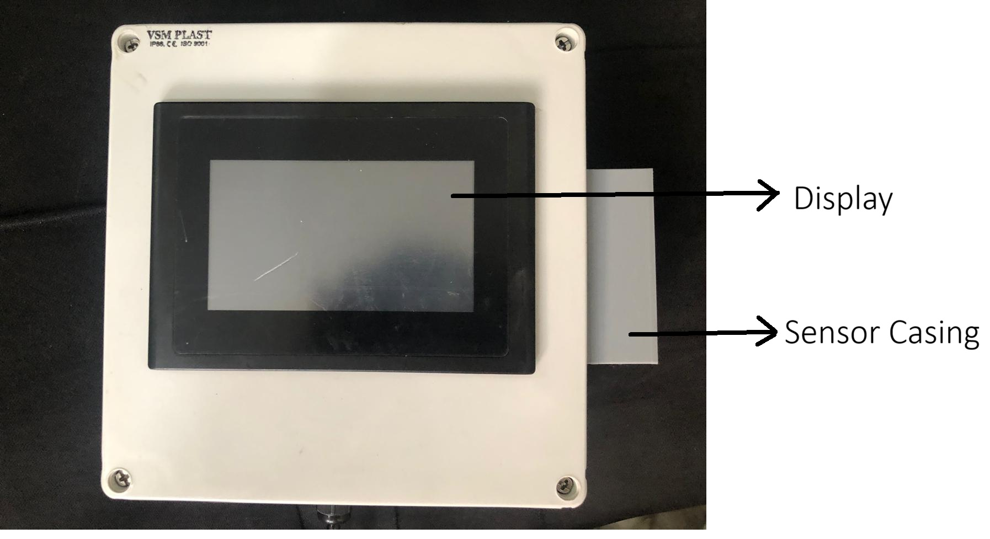
Figure 1: Main Monitoring Device
Ensure the SIM card is properly inserted in the SIM slot before installation.

2. Installation & Power
Mounting Guidelines:
- Height: Mount 4 to 5 feet (1.2–1.5 meters) from the floor level.
- Location: Install in a central area with natural air circulation.
- Avoid: Do not mount directly above toilets, urinals, or washbasins. Keep away from exhaust vents, windows, direct water splashes, and cleaning spray. Do not enclose in cabinets.
Mounting Procedure:
- First, attach the four mounting brackets to the back corners of the device using the provided screws.
- Hold the device against the wall at the recommended mounting height and mark the mounting holes.
- Drill holes and insert wall plugs if required.
- Align the device brackets with the drilled holes and secure the device firmly to the wall with screws.
- After installation, verify that the device is securely fixed and positioned upright.
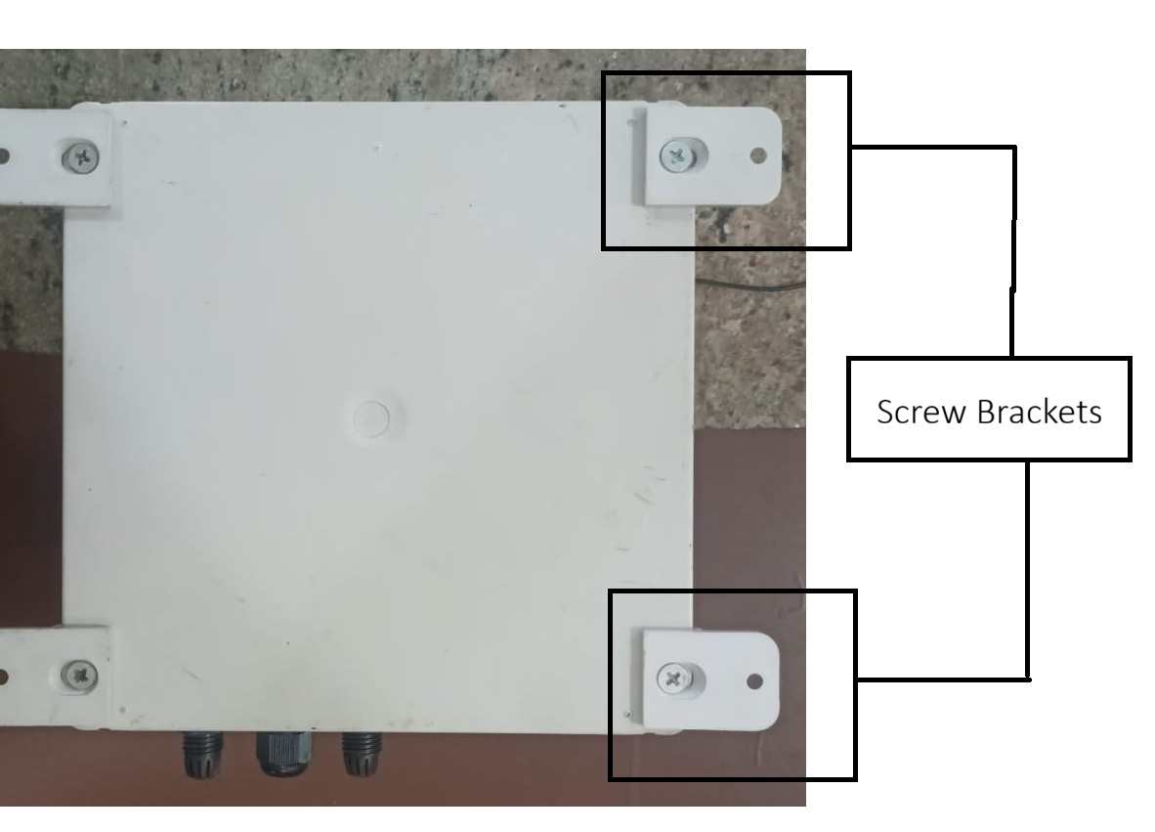
Figure 2: Back of the device showing the proper attachment of the four corner mounting brackets.
Powering On:
- Connect the supplied power adapter to the device and plug it into a standard 110–230V AC electrical socket.
- Switch on the power supply. The boot-up sequence will begin automatically.
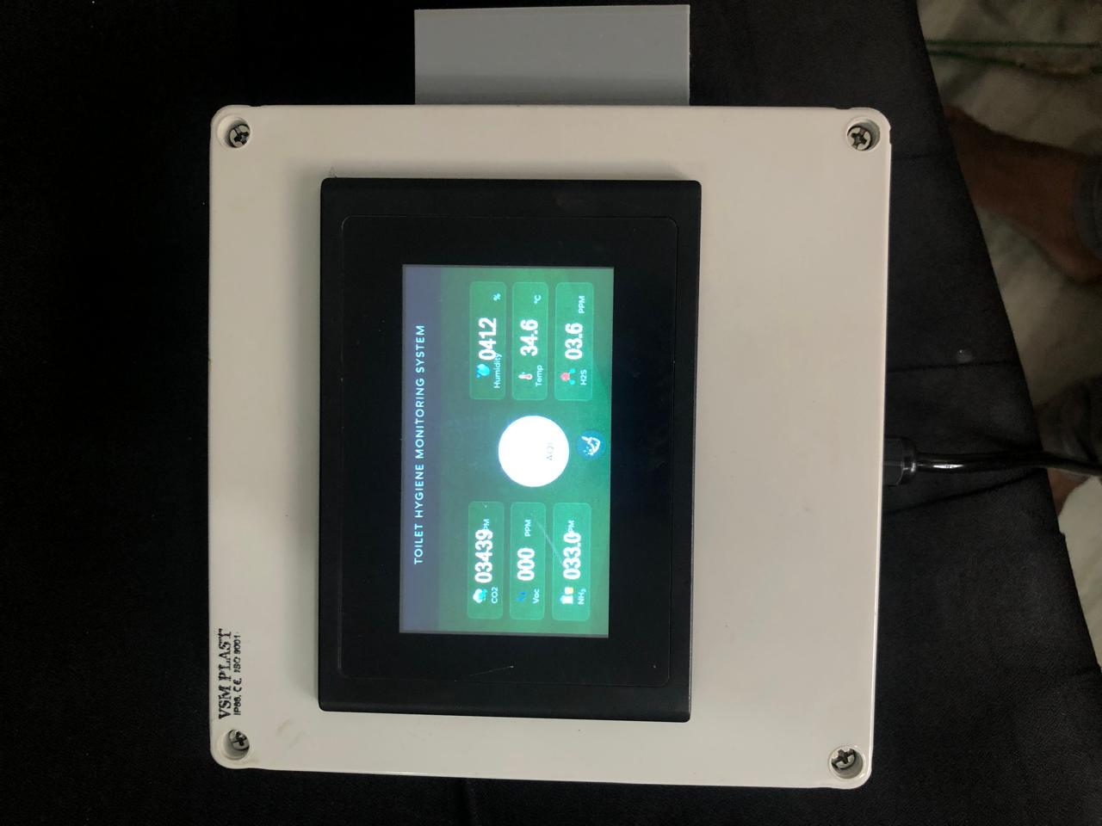
Figure 3: Active Display Screen showing real-time sensor readings.
Startup & Stabilization:
- Initial sensor warm-up takes approximately 3–10 minutes.
- Gas readings may fluctuate slightly during this period before stabilizing.

3. On-Screen Interface & Controls
The device features an interactive touch display providing a real-time overview of the restroom's environmental conditions. The dashboard layout is organized into three main sections:
- Left Column (Gas Levels): Displays current readings for CO₂ (Carbon Dioxide), VOC (Volatile Organic Compounds), and NH₃ (Ammonia) in PPM (Parts Per Million).
- Center (Hygiene Status & Controls): Displays the overall AQI (Air Quality Index) score in the main circle, with the interactive Clean Button located directly below it.
- Right Column (Environment & Gases): Displays Humidity (%), Temperature (°C), and H₂S (Hydrogen Sulphide) in PPM.
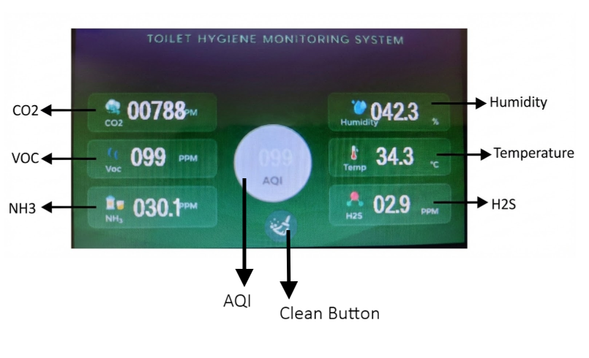
Figure 4: Main Display Interface showing the layout of real-time sensor variables and the Clean Button.
Clean Button Maintenance Controls:
The interactive Clean Button allows maintenance staff to control the device directly from the screen:
- Cleaning Mode (Tap 1 Time): Tap the Clean Button exactly once when actively cleaning the restroom. This temporarily prevents the sensors from triggering false alerts caused by strong cleaning chemical vapors.
- System Reset (Tap 5 Times): Tap the Clean Button 5 times rapidly to perform a complete system reset. Use this function if the device loses its network connection or if the sensor readings remain stuck or highly unstable.

4. Cloud Dashboard Access
After hardware installation and network connection, you can access your real-time data through the web-based monitoring platform.
1. Portal Login:
- Click on the provided web http://thms.uniolabs.com:3000/?kiosk dashboard link to open the THMS login portal.
- Enter the Username and Password supplied by our team.
- Click the Log in button to securely access the system.
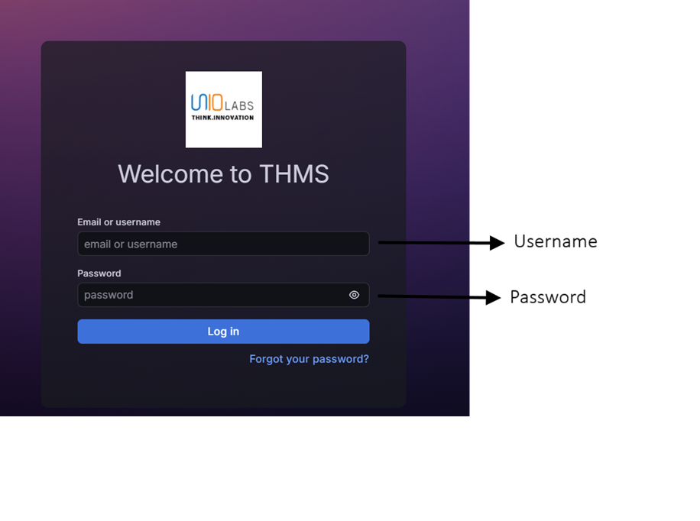Figure 5: THMS Portal Login Page showing where to enter your credentials.
2. Accessing Your Device Data:
- Once logged in, navigate to the Hygiene Monitor (Live) dashboard.
- Locate the Toilet (IMEI) dropdown menu at the top of the dashboard.
- Enter correct IMEI Number: Click the dropdown and type or select your device's unique IMEI number to load its specific telemetry data.

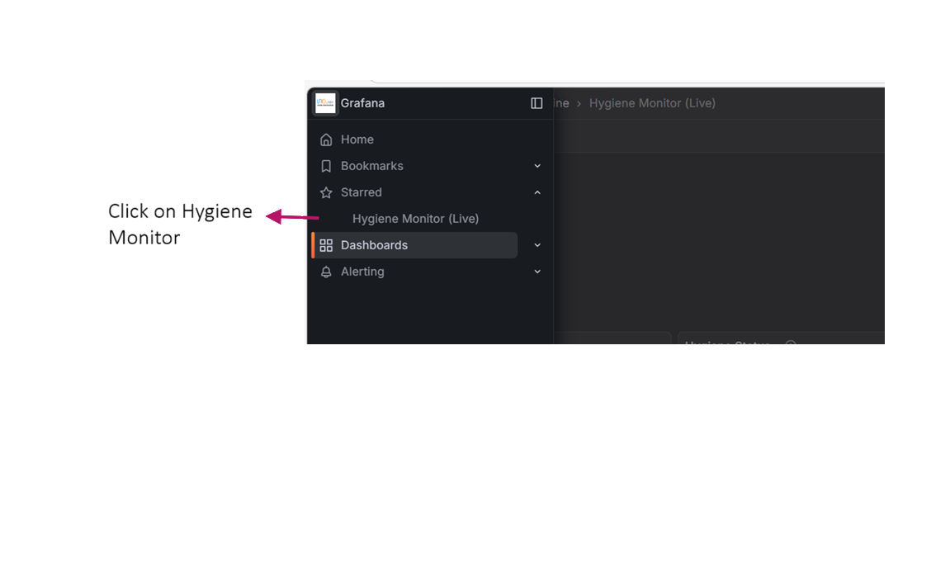
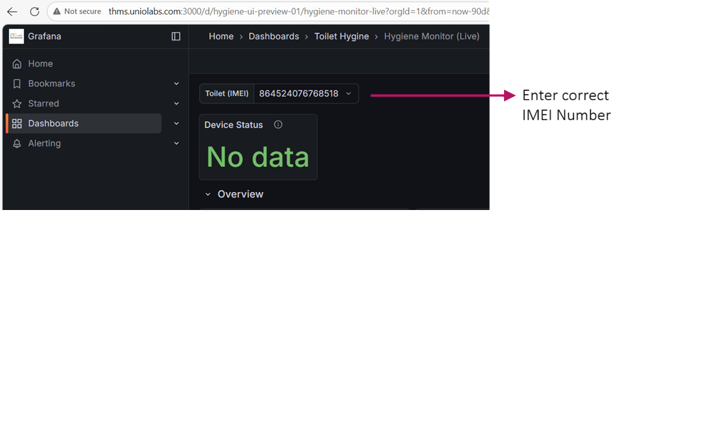
Figure 6: Dashboard view showing the dropdown menu where the correct IMEI number must be entered.
- Verify that live data from your installed device is visible.
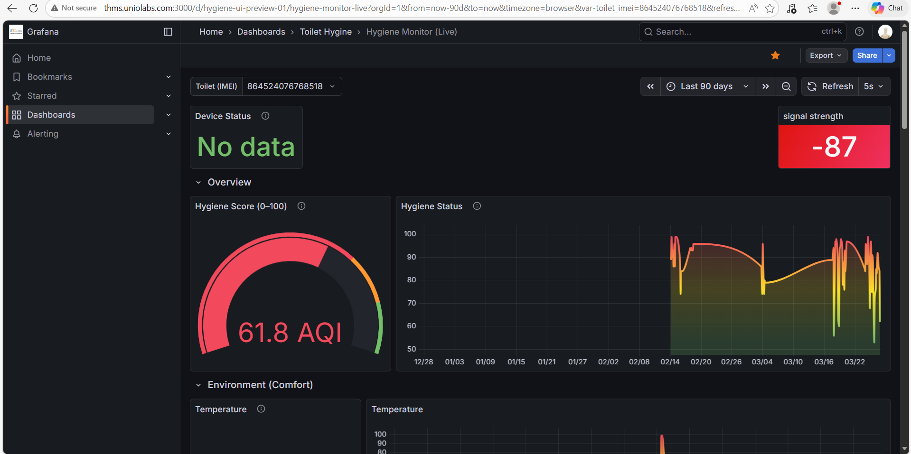
Figure 7: Live Monitoring Dashboard showing the loaded data, including Signal Strength, Hygiene Score, and Environmental parameters.

Understanding the Overview Dashboard:
Once the correct device data is loaded, the Overview section provides a quick visual summary of the restroom's air quality.
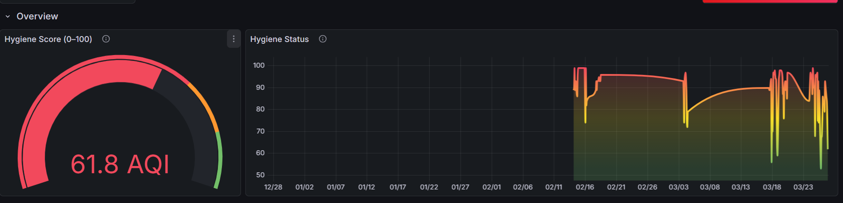
Figure 8: The Overview panel displaying the real-time gauge and historical tracking graph.
- Hygiene Score (0-100): This gauge displays the real-time Air Quality Index (AQI). The color-coded arc helps you instantly identify the current status (e.g., Red indicates poor air quality requiring attention, while Green indicates clean air).
- Hygiene Status Graph: This line chart tracks the AQI score over time. By looking at the peaks and dips in the graph, facility managers can identify trends—such as specific times of day when restroom air quality consistently drops—to better schedule cleaning and maintenance staff.
Environmental Monitoring (Comfort Levels): Scroll down on the dashboard to view the specific environmental conditions inside the restroom. This section helps facility managers ensure the space remains comfortable and well-ventilated.
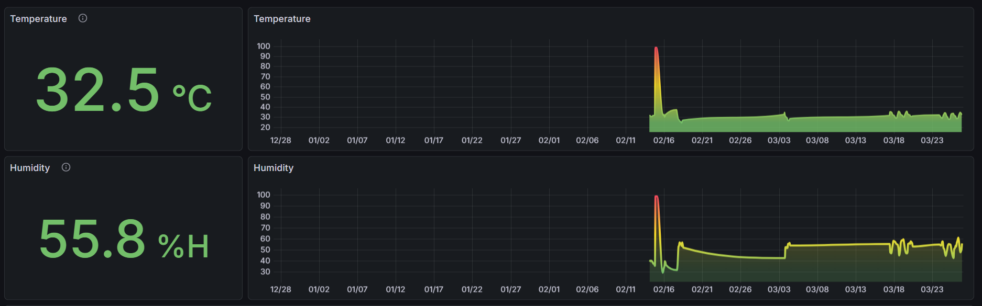 Figure 9: Dashboard panels displaying real-time and historical data for Temperature and Humidity.
- Temperature: The top panel displays the current ambient temperature in degrees Celsius (°C) on the left, alongside a historical graph on the right. Monitoring this helps identify if the air conditioning or ventilation systems are functioning properly.
- Humidity: The bottom panel displays the current relative humidity percentage (%H) and its historical trend. High humidity levels combined with poor ventilation can lead to increased odors and potential moisture issues, making this a critical metric to track.
Detailed Gas Trend Analysis: For a deeper dive into specific air quality factors, the dashboard includes a comprehensive graph that tracks all monitored gases simultaneously.
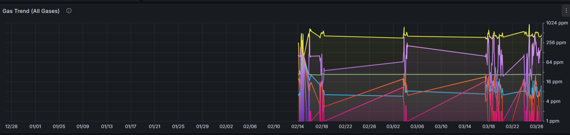Figure 10: The Gas Trend (All Gases) graph showing historical ppm levels.
- Comprehensive Tracking: This multi-line graph plots the historical data of all individual sensor readings (such as Carbon Dioxide, VOCs, Ammonia, and Hydrogen Sulphide) on a single chart.
- Interactive Hover Feature: To easily identify which colored line represents which gas, simply move your mouse cursor over the graph. Hovering over a specific point will highlight that factor and display a pop-up showing the exact gas name, its value (in ppm), and the recorded timestamp.
- Logarithmic Scale (PPM): The axis on the right side uses a scale from 1 ppm up to 1024 ppm. This allows you to clearly see very small trace amounts of certain gases alongside much higher concentrations of others without the chart looking distorted.
- Event Identification: By looking for sudden spikes in specific lines, facility managers can easily identify exact times of high restroom traffic (which might cause CO₂ or NH₃ spikes) or intense cleaning sessions (which often cause VOC spikes).
Gas Snapshot (Gauges): For an immediate, real-time look at individual air quality factors, the dashboard includes a dedicated gauges section.
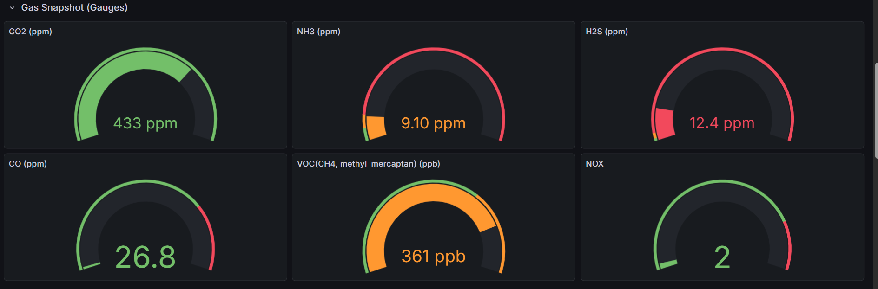Figure 11: The Gas Snapshot panel displaying individual color-coded gauges for specific gases.
- Individual Gas Monitoring: This section features dedicated gauges for each critical gas detected by the system, including Carbon Dioxide (CO₂), Ammonia (NH₃), Hydrogen Sulphide (H₂S), Carbon Monoxide (CO), VOCs, and NOX.
- Real-Time Values & Units: Each gauge displays the exact current numerical reading along with its specific unit of measurement, such as ppm (parts per million) or ppb (parts per billion).
- Color-Coded Status: The outer rings of the gauges use an intuitive traffic-light color system (Green for normal/safe, Orange for elevated/warning, and Red for critical/poor). This allows facility managers to see at a single glance if any specific gas concentration has reached an undesirable level without needing to analyze a complex chart.

Device Health Monitoring (Network & Battery):
Beyond environmental data, the dashboard also tracks the operational health of the device itself to ensure continuous, uninterrupted monitoring.
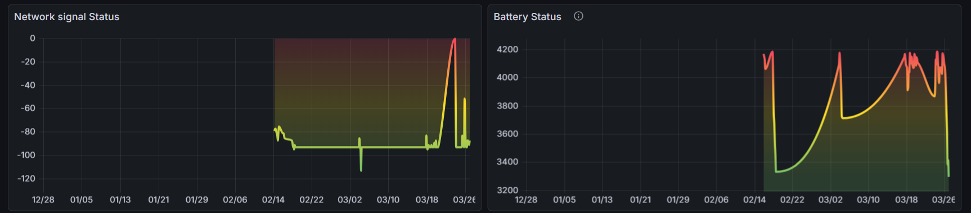
Figure 12: Device Health panels displaying historical data for Network signal Status and Battery Status.
- Network signal Status: This graph monitors the strength of the device's 4G LTE cellular connection over time. If the device goes offline or experiences data synchronization delays, facility managers can check this graph to see if a drop in signal strength caused the issue.
- Battery Status: The system includes an integrated 5000 mAh Li-Po battery for backup power. This graph tracks the battery's voltage levels (typically ranging from around 3200mV when depleted to 4200mV when fully charged). It helps verify that the device is receiving main power properly and shows how long the system sustains itself during power outages.

Dashboard Navigation & Real-Time Status: At the top right corner of the dashboard, you will find essential controls for navigating your data and checking the immediate connection status of your device.
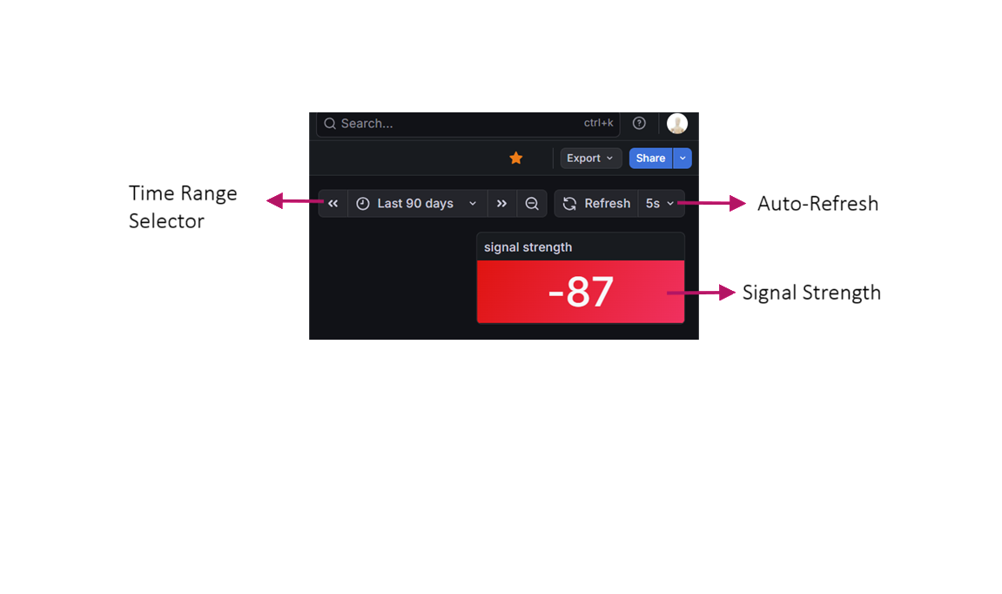Figure 13: Dashboard time controls, auto-refresh settings, and real-time signal strength indicator.
- Time Range Selector: The dropdown menu (showing "Last 90 days" in the example) allows you to adjust the timeframe of the historical data displayed on all graphs. You can zoom in to view data from the last 24 hours or zoom out to review monthly trends.
- Auto-Refresh: The dashboard is designed for live monitoring. The refresh setting (e.g., "5s") means the page will automatically pull the newest data from the device every 5 seconds. You can also click the Refresh button to manually force an immediate update.
- Signal Strength: This dedicated panel displays the real-time cellular (4G LTE) connection strength of the device. The number (measured in dBm) helps facility managers verify that the device has a stable connection to the cloud for uninterrupted data transmission.

5. Basic Troubleshooting
- Device Not Powering On: Check that the power adapter is securely connected to the electrical socket and the device. Turn off the power supply for 30 seconds and restart.
- Blank Screen (Power Outage): If main power drops, the device automatically switches to battery backup. The display turns off intentionally to conserve power, but the system continues monitoring and storing data.
- Device Offline / No Network: Ensure the 4G SIM card is inserted properly. Avoid installing inside metal enclosures or areas with weak signal coverage. Perform a System Reset (tap the Clean Button 5 times rapidly).
- Data Not Updating on Dashboard: Confirm the device screen status shows "Online". Verify that you have entered the correct IMEI number in the dashboard dropdown menu.
- Unstable Sensor Readings: Always allow a 10-minute stabilization period after powering on. Ensure the device is not mounted too close to exhaust fans, direct heat, or water sources. If cleaning chemicals are being sprayed nearby, remember to tap the Clean Button once to activate Cleaning Mode.
- Incorrect Temperature or Humidity Readings: Ensure the device is not mounted near direct heat sources (like heaters or sunlight) or water sources (like washbasins or steam). Allow time for readings to stabilize after sudden environmental changes in the restroom. If the issue persists, sensor calibration may require service inspection.

